LOWERED FLOOR – VW CADDY MAXI
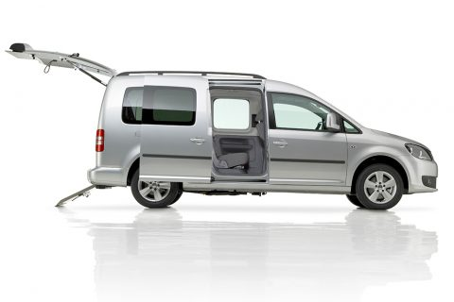

- Lowered floor from rear up to 2nd seat row
- 4-point wheelchair tie-down system with an adjustable 3-point seatbelt for the wheelchair passenger
- Modified fuel tank and exhaust system to accommodate a deep and level lowered floor
- Original seats in the second row are preserved after conversion
- Ramp: Double folding lightweight ramp with clear-view design what allows to view through the back window
- Lowered floor fully covered with matching upholstery
- The center part or the rear bumper will be replaced on hatch, thus maintaining the original look
- The original parking sensors remain functional after conversion

DIMENSIONS
Entrance height: 142 cm/56 inches | Interior height: 147 cm/58 inches
Length of lowered floor: 147 cm/58 inches | Width of lowered floor: 81 cm/32 inches
www.asquithmobilitysolutions.com.au

