Ergonomic Radial Accelerator and Brake Lever

The Ergonomic Radial Accelerator and Brake Lever is a quality hand control designed for operation with limited dexterity.
The choice of ergonomic palm or lever grip handle coupled with the ability to customise the handle weight and rotation totally personalises the product to the user’s individual strengths, preferences, and capabilities.

Models:

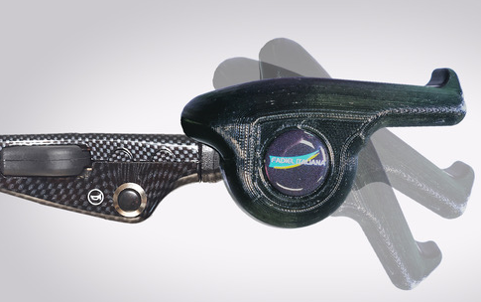
Palm Grip
The palm grip has a V-shape handle to rest your palm whilst driving. The rotation is smooth and perfectly balanced to your hand.

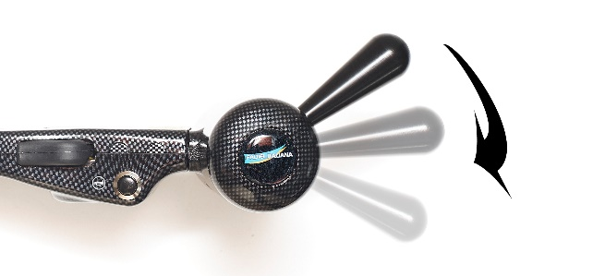

Lever Grip
The lever grip handle has a curved finish that allows your hand to rest on the handle as you turn your wrist to accelerate.

Features
- Left- and right-hand versions
- Easy height and angle adjustment
- 70 degrees of rotation on handle for acceleration
- Adjustable rotation weight
- Smooth acceleration with minimal fatigue
- Acceleration safety cut-out mechanism
- Brake lock feature
- Compatible with original electronics
- Knee airbag compatibility
- Suitable for fitment (and re-fit) in all types of vehicles
- Easily turned off enabling regular foot operation
- Can be incorporated with voice command for activation of auxiliary controls
- Knee airbag compatibility
- Colours: black, carbon

