Easy Drive

The Easy Drive is a hand control driving system designed to be fitted on the left-hand side of the driver seat. The Easy Drive comes in three models – Push/Pull, Push/Radial and Floor brake. The levers have the ability to be customised to suit the user’s individual strengths, preferences, and capabilities. The result is a highly performing, intuitive product, and the acceleration is comfortable and easy to manage.

Easy Drive Models
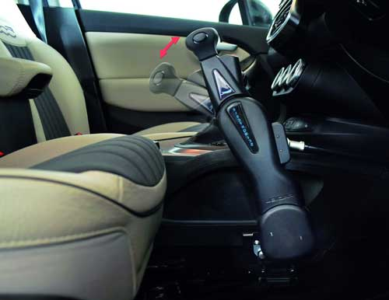
Push/Pull
The Push/Pull Easy Drive combines a forward motion to brake and a pull motion to accelerate electronically.

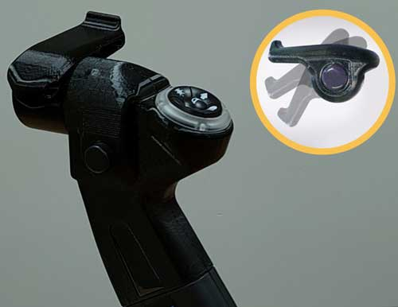

Push/Radial
The Push/Radial Easy Drive combines a forward motion to brake and a radial action of the wrist to accelerate electronically.

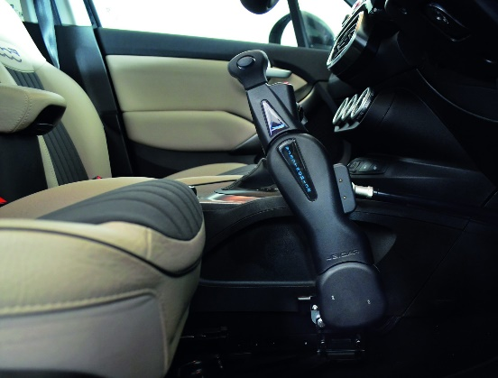
Floor Brake
The Floor Brake Easy Drive allows the brake to be managed by simply pushing the lever forward, ensuring braking with minimum effort. Can be combined with a Satellite Accelerator.

